When an interrupt occurs, the processor follows a specific sequence of actions to handle the event. Here's a brief outline of the steps involved:

- Interrupt Recognition: The processor detects that an event requires immediate attention, either from within the system or from an external device.
- Status Saving: To maintain the current process's state, the processor saves all important settings.
- Interrupt Masking: Initially, the processor ignores all other interruptions to focus on the current one.
- Interrupt Acknowledgment: The processor acknowledges the interrupt and informs the interrupting device that it has been received.
- Interrupt Service Routine: The processor starts dealing with the issue by executing the ISR, which handles the specific task associated with the interrupt.
- Restoration and Return: Once the problem is resolved, the processor restores all saved settings, ensuring everything returns to normal as if nothing happened.
This sequence allows the processor to efficiently manage interruptions and maintain system stability and responsiveness.

Instruction Formats
Instruction format defines how instructions are represented in a computer’s memory. There are different types of instruction formats, including zero, one, two, and three-address instructions.
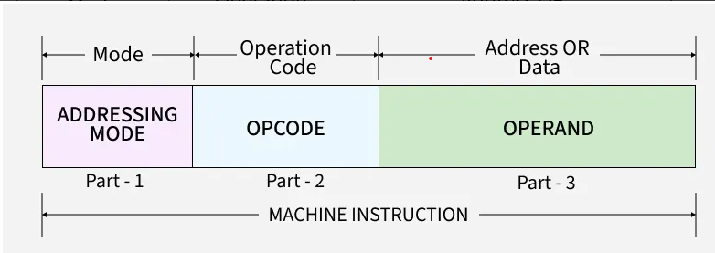
Defines how the CPU decodes and executes instructions.
- Opcode: This field specifies the operation to be performed by the CPU, such as addition, subtraction, or data transfer.
- Operands: These fields contain the data or references (addresses) to data on which the operation acts.
- Addressing Mode: This specifies how to interpret or locate the operand, such as direct, indirect, or immediate addressing.

Types of Instruction Formats
Instruction formats are classified into zero, one, two, and three-address types, depending on how many address fields they have. Each type works differently and is used in various ways in computer architecture.
NOTE: We will use the X = (A+B)*(C+D) expression to showcase the procedure.

Zero Address Instructions
These instructions do not specify any operands or addresses. Instead, they operate on data stored in registers or memory locations implicitly defined by the instruction. For example, a zero-address instruction might simply add the contents of two registers together without specifying the register names.
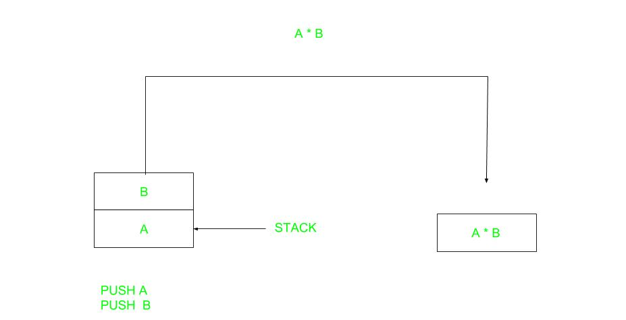Zero Address Instruction
A stack-based computer does not use the address field in the instruction. To evaluate an expression, it is first converted to reverse Polish Notation i.e. Postfix Notation.
Expression: X = (A+B)*(C+D)
Postfixed : X = AB+CD+*
TOP means top of stack
M[X] is any memory location
Instruction | Stack (TOP Value After Execution)
PUSH A | TOP = A
PUSH B | TOP = B
ADD | TOP = A + B
PUSH C | TOP = C
PUSH D | TOP = D
ADD | TOP = C + D
MUL | TOP = (C + D) * (A + B)
POP X | M[X] = TOP

One Address Instructions
These instructions specify one operand or address, which typically refers to a memory location or register. The instruction operates on the contents of that operand, and the result may be stored in the same or a different location. For example, a one-address instruction might load the contents of a memory location into a register.
This uses an implied ACCUMULATOR register for data manipulation. One operand is in the accumulator and the other is in the register or memory location. Implied means that the CPU already knows that one operand is in the accumulator so there is no need to specify it.
One Address Instruction
Expression: X = (A+B)*(C+D)
AC is accumulator
M[] is any memory location
M[T] is temporary location
Instruction | Stack / Register (AC / M[])
AC = A | AC = A
AC = AC + B | AC = A + B
M[T] = AC | M[T] = A + B
AC = C | AC = C
AC = AC + D | AC = C + D
M[] = AC | M[] = C + D
AC = AC * M[T] | AC = (A + B) * (C + D)
M[X] = AC | M[X] = (A + B) * (C + D)

Two Address Instructions
These instructions specify two operands or addresses, which may be memory locations or registers. The instruction operates on the contents of both operands, and the result may be stored in the same or a different location. For example, a two-address instruction might add the contents of two registers together and store the result in one of the registers.
This is common in commercial computers. Here two addresses can be specified in the instruction. Unlike earlier in one address instruction, the result was stored in the accumulator, here the result can be stored at different locations rather than just accumulators, but require more number of bit to represent the address.
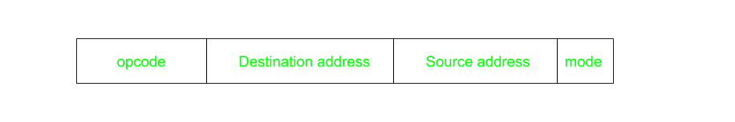Two Address Instruction
Here destination address can also contain an operand.
Expression: X = (A+B)*(C+D)
R1, R2 are registers
M[] is any memory location
Instruction | Registers / Memory (R1, R2, M[])
R1 = A | R1 = A
R1 = R1 + B | R1 = A + B
R2 = C | R2 = C
R2 = R2 + D | R2 = C + D
R1 = R1 * R2 | R1 = (A + B) * (C + D)
M[X] = R1 | M[X] = (A + B) * (C + D)

Three Address Instructions
These instructions specify three operands or addresses, which may be memory locations or registers. The instruction operates on the contents of all three operands, and the result may be stored in the same or a different location. For example, a three-address instruction might multiply the contents of two registers together and add the contents of a third register, storing the result in a fourth register.
This has three address fields to specify a register or a memory location. Programs created are much short in size but number of bits per instruction increases. These instructions make the creation of the program much easier but it does not mean that program will run much faster because now instructions only contain more information but each micro-operation (changing the content of the register, loading address in the address bus etc.) will be performed in one cycle only.
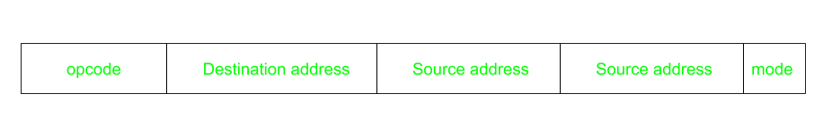Three Address Instruction
Expression: X = (A+B)*(C+D)
R1, R2 are registers
M[] is any memory location
Instruction | Description
R1 = A | Load value A into R1
R1 = R1 + B | Add B to R1
M[T1] = R1 | Store R1 into memory at M[T1]
R2 = C | Load value C into R2
R2 = R2 + D | Add D to R2
M[T2] = R2 | Store R2 into memory at M[T2]
R1 = M[T1] | Load M[T1] into R1
R1 = R1 * M[T2] | Multiply R1 by M[T2] and store in R1
M[X] = R1 | Store R1 into memory at M[X]

CPU Organization and Instruction Formats
Generally, CPU organization is of three types based on the number of address fields:
- Single Accumulator Organisation: Uses one special register (called an accumulator) to store and process data for operations.
- General Register Organisation: Uses several general-purpose registers to hold operands (data) for operations.
- Stack Organisation: Works with a stack, processing data using the top elements without directly specifying operands.

To get rid of data hazards inside a pipelined system, you can use the following techniques:

Types of Data Hazards
- RAW (Read After Write): Instruction needs a value that previous instruction hasn’t written yet.
- WAR (Write After Read): Instruction writes before previous instruction reads.
- WAW (Write After Write): Two instructions write to the same location in wrong order.

Solutions
- Forwarding (Data Bypassing):
  - Send the result from the EX or MEM stage directly to the next instruction without waiting for it to be written back to the register file.
  - Example: Output of ALU is forwarded to the next instruction’s input.
- Pipeline Stalling (Inserting Bubbles):
  - Temporarily halt the pipeline until the required data is available.
  - This prevents incorrect execution but reduces performance.
- Instruction Reordering (Compiler Technique):
  - Compiler rearranges instructions so that independent instructions execute while waiting for data, reducing stalls.
- Register Renaming (for WAR/WAW):
  - Use different physical registers to avoid conflicts when multiple instructions write/read the same logical register.

✅ These methods ensure correct execution while minimizing performance loss.

